NAME:- MUHAMMAD ZOHAIB AHMER. (FA20-BCS-038)

SANAN (SP20-BCS-038).

DATED :- 2023.12.27

CC LAB TERMINAL

Q1: Description of the project??

ANS:

The primary focus revolves around the intricate automation of strings, alphabets, and related elements. The design encompasses a sophisticated system that not only manipulates but also interprets and transforms various types of strings. The automation processes intricately define the handling of alphanumeric sequences, ensuring efficiency and precision in their manipulation. Each step of the automation is meticulously crafted to provide a seamless experience, with the ability to process diverse sets of strings with varying complexities. The alphabet, a fundamental component of linguistic structures, undergoes a tailored automation process that accounts for linguistic nuances, ensuring accurate and contextually relevant transformations. The output of this automation project displays each meticulously crafted step, offering transparency into the inner workings of the system. This project represents a significant stride in the realm of string manipulation and alphabet automation, providing a versatile and powerful tool for applications ranging from linguistic analysis to data processing.

Q2: Which functions is used ??

ANS:

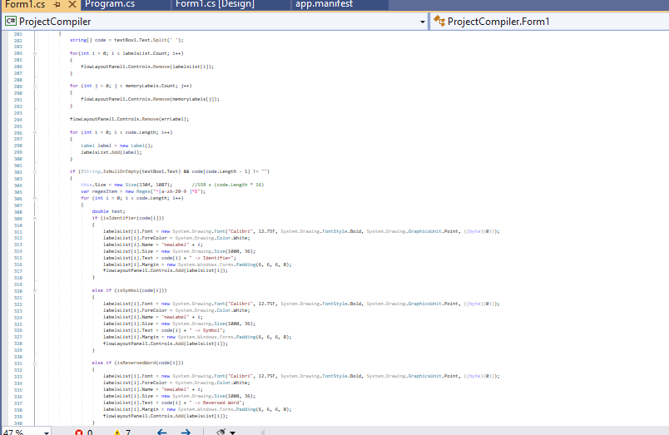

Output:

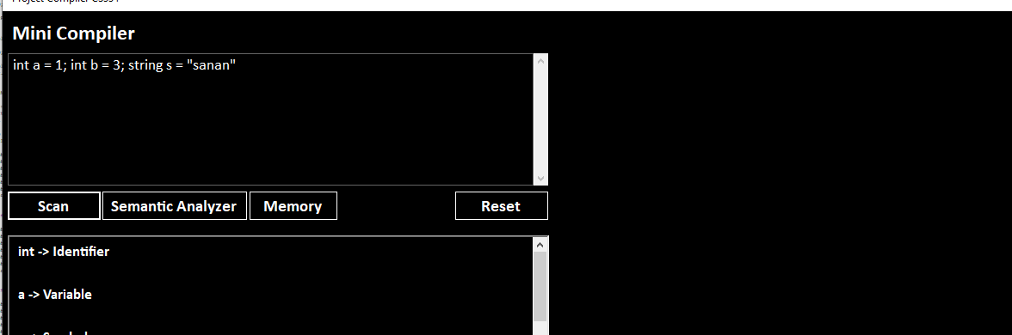

Q3: Show the input

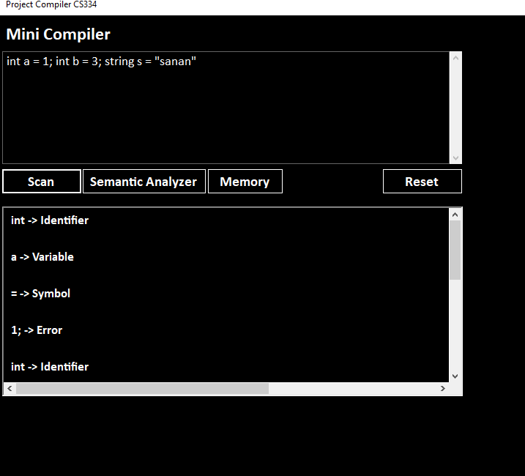

Symantic analysis

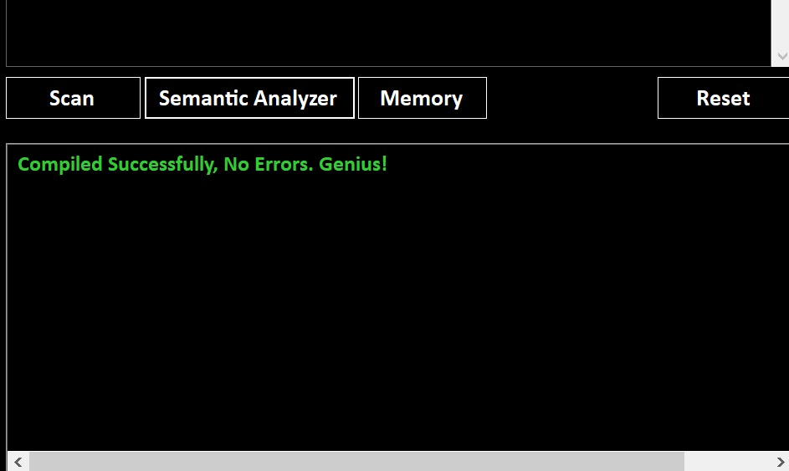

Q4:How function works?

Ans:-The provided C# code defines a method named main Analyze that takes an integer parameter which Button and returns a boolean value. The method is designed to analyze code input from a TextBox . It splits the input into an array of strings, initializes some variables, and proceeds to analyze the code in a loop. The analysis involves checking for identifiers, variables, and specific keywords.